The Online Shopping System Software requirements Specification (SRS) report outlines

the essential specifications and requirements needed to develop a dependable and user-

friendly online shopping platform. In the current digital era, e-commerce has become an

essential part of the retail environment. This SRS document offers the framework for

creating an efficient and user-friendly online purchasing experience for both

administrators and customers.

This project's main goal is to design, develop, and implement an online shopping system

that satisfies the diverse demands of modern consumers. This system will offer a wide

range of products, user-friendly interfaces, secure payment options, and efficient order

management for clients. It will also give administrators access to comprehensive inventory

and sales administration tools

The Online Shopping System Software requirements Specification (SRS) report outlines

the essential specifications and requirements needed to develop a dependable and user-

friendly online shopping platform. In the current digital era, e-commerce has become an

essential part of the retail environment. This SRS document offers the framework for

creating an efficient and user-friendly online purchasing experience for both

administrators and customers.

This project's main goal is to design, develop, and implement an online shopping system

that satisfies the diverse demands of modern consumers. This system will offer a wide

range of products, user-friendly interfaces, secure payment options, and efficient order

management for clients. It will also give administrators access to comprehensive inventory

and sales administration tools

The Online Shopping System Software requirements Specification (SRS) report outlines

the essential specifications and requirements needed to develop a dependable and user-

friendly online shopping platform. In the current digital era, e-commerce has become an

essential part of the retail environment. This SRS document offers the framework for

creating an efficient and user-friendly online purchasing experience for both

administrators and customers.

This project's main goal is to design, develop, and implement an online shopping system

that satisfies the diverse demands of modern consumers. This system will offer a wide

range of products, user-friendly interfaces, secure payment options, and efficient order

management for clients. It will also give administrators access to comprehensive inventory

and sales administration tools

The Online Shopping System Software requirements Specification (SRS) report outlines

the essential specifications and requirements needed to develop a dependable and user-

friendly online shopping platform. In the current digital era, e-commerce has become an

essential part of the retail environment. This SRS document offers the framework for

creating an efficient and user-friendly online purchasing experience for both

administrators and customers.

This project's main goal is to design, develop, and implement an online shopping system

that satisfies the diverse demands of modern consumers. This system will offer a wide

range of products, user-friendly interfaces, secure payment options, and efficient order

management for clients. It will also give administrators access to comprehensive inventory

and sales administration tools

**ABSTRACT**

Software Systems Specifications (SRS) for the Online Shopping System outlines the essential specifications and requirements needed to develop a dependable and user-friendly online shopping platform. In the current digital era, e-commerce has become an essential part of the retail environment. This SRS document offers the framework for creating an efficient and user-friendly online purchasing experience for both administrators and customers. Customer can login to the system to maintain his account information, such as changing phone number, address, and credit card details, and check the status of his orders. Upon order received, the sales staff will process the order by change to customer’s credit card. Once the order has been charged, he will mark the order as paid and pass to courier company and deliver them to customers. If the items customer ordered is out of stock, then the order will be marked as hold. This project's main goal is to design, develop and implement an online shopping system that satisfies the diverse demands of modern consumers. This system will offer a wide range of products, user-friendly interfaces, secure payment options and efficient order management for clients. It will also give administrators access to comprehensive inventory and sales administration tools.

**INTRODUCTION**

**1.1 PURPOSE**

In today's fast-paced digital age, online shopping has become an indispensable part of our lives. The convenience it offers, coupled with a vast array of choices and seamless transactions, has revolutionized the way we shop. To cater to this growing trend and enhance user experience, the development of an Online Shopping System is paramount.

**1.2 INTENDED AUDIENCE**

The Online Shopping System is envisioned as a comprehensive platform that provides users with a seamless and intuitive shopping experience. This system aims to bridge the gap between consumers and retailers, offering a virtual marketplace where users can browse, select, and purchase products or services from the comfort of their homes.

**1.3 SCOPE**

The scope of the Online Shopping System outlined in the SRS encompasses user management, product catalogue, shopping cart functionality, secure checkout process, order management, an administrative panel, stringent security measures, responsive design for various devices, and scalability for future expansion, ensuring a seamless and secure shopping experience for users while providing efficient management tools for administrators.

**1.4 DEFINITION**

The SRS document provides a detailed description of the system's purpose, functionality, and interactions with users and other systems. It outlines the various modules, components, and interfaces that constitute the Online Shopping System, along with their respective specifications and constraints.

**1.5 REFERENCES**

References for the Online Shopping System with Software Requirements Specification (SRS) include industry standards such as ISO/IEC 25010 for software quality, OWASP guidelines for web application security, and best practices from e-commerce platforms like Shopify and Magento. Additionally, academic sources on software engineering methodologies and requirements engineering principles contribute to the development of a robust and comprehensive SRS for the online shopping system.

**OVERALL DESCRIPTION**

**2.1 USER INTERFACE**

The User Interface (UI) design for the Online Shopping System, as per the Software Requirements Specification (SRS), prioritizes intuitive navigation, visually appealing product displays, and seamless interaction across devices. Utilizing modern design principles and user experience (UX) techniques, the UI aims to enhance user engagement, simplify the shopping process, and ensure accessibility for diverse user demographics. Integration of responsive design elements ensures optimal usability across various screen sizes and resolutions, fostering a satisfying shopping experience for all users.

**2.2 SYSTEM INTERFACE**

The System Interface design for the Online Shopping System, as specified in the Software Requirements Specification (SRS), involves integration with secure payment gateways for seamless transaction processing, interaction with inventory management systems for real-time stock updates, and communication with shipping carriers for order fulfilment and tracking. Additionally, APIs may be utilized to connect with third-party services for features like customer reviews, social media integration, and analytics, ensuring a robust and interconnected ecosystem for the online shopping platform.

**2.3 SOFTWARE AND HARDWARE REQUIREMENTS**

**Software:** Web server (e.g., Apache), database management system (e.g., MySQL), programming languages (e.g., HTML/CSS, JavaScript, Python) and security tools (e.g., Firewall).

**Hardware:** Servers with sufficient processing power and memory to handle website traffic, storage systems for database management, and network infrastructure to ensure reliable connectivity. Additionally, client devices such as computers, smartphones, and tablets are required for accessing the online shopping platform.

**2.4 CONSTRAINTS**

* Compliance with data protection regulations (e.g., GDPR) and industry standards for secure handling of user information.
* Integration limitations with third-party services or APIs, potentially affecting the availability of certain features.
* Technical constraints such as platform compatibility, browser support, and scalability considerations to accommodate varying user loads and growth.

**2.5 USER CHARACTERISTICS**

User characteristics for the Online Shopping System, as detailed in the Software Requirements Specification (SRS), encompass a diverse range of demographics, including tech-savvy individuals, elderly users, and individuals with varying levels of digital literacy. The system should be designed with intuitive navigation and clear instructions to accommodate users of all backgrounds and skill levels. Additionally, accessibility features should be incorporated to ensure usability for users with disabilities, such as screen readers for visually impaired users.

**SYSTEM FEATURE AND REQUIREMENTS**

**3.1 FUNCTIONAL REQUIREMENTS**

* User registration and login functionalities to access personalized accounts.
* Product browsing, searching, and filtering options to facilitate efficient navigation.
* Shopping cart management, allowing users to add, remove, and modify items before checkout.
* Secure payment processing and order confirmation mechanisms to ensure smooth transactions.

**3.2 DIAGRAMS**

**3.2.1 USE CASE DIAGRAM**

The Use Case Diagram for the Online Shopping System, as per the Software Requirements Specification (SRS), illustrates interactions between actors and system functionalities. Key use cases include User Registration, Product Search and Browsing, Adding Items to Cart, Checkout Process, and Admin Management. These use cases delineate the primary functionalities required for users and administrators to interact with the system effectively.

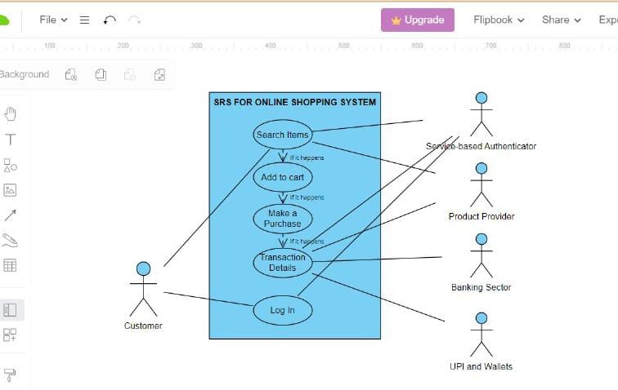

**3.2.2 CLASS DIAGRAM**

The Class Diagram for the Online Shopping System, outlined in the Software Requirements Specification (SRS), delineates the various classes and their relationships within the system. Key classes include User, Product, Cart, Order, Payment, and Admin. Associations and attributes within these classes define the structure and interactions essential for managing user accounts, products, shopping carts, orders, payments, and administrative functions within the system.

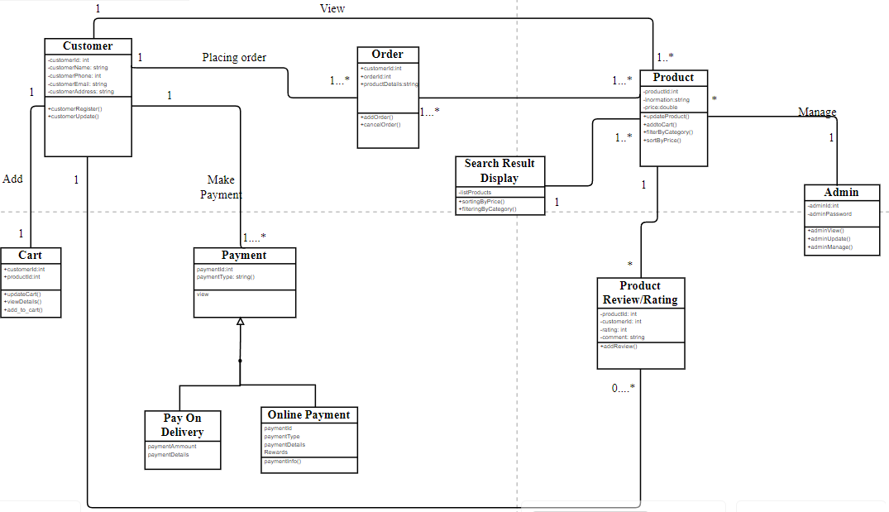

**3.2.3 SEQUENCE DIAGRAM**

The Sequence Diagram for the Online Shopping System, as outlined in the Software Requirements Specification (SRS), illustrates the chronological sequence of interactions between actors and system components during key processes such as user registration, product purchase, and order tracking. It showcases the flow of messages and actions between actors (users, administrators) and system elements (e.g., user interface, database, payment gateway) to accomplish specific tasks within the system.

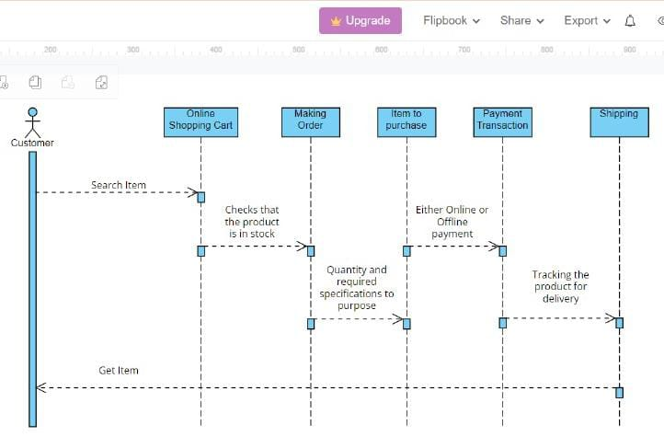

**3.2.4 FLOWCHART**

The Flowchart for the Online Shopping System, in accordance with the Software Requirements Specification (SRS), maps out the step-by-step process of key user interactions, from browsing products to completing a purchase. It visualizes the flow of activities including user authentication, product selection, cart management, checkout, and order fulfilment. Additionally, it depicts decision points, loops, and system actions, providing a comprehensive overview of the system's functionality and user journey.

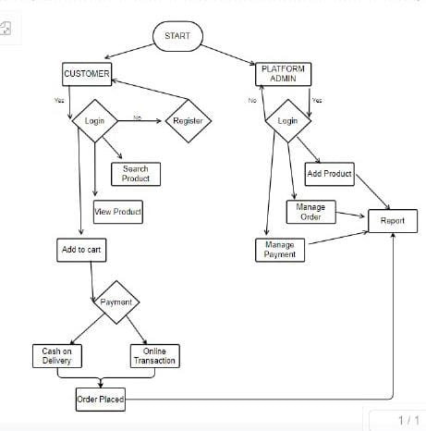

**3.3 EXTERNAL INTERFACE REQUIREMENTS**

External Interface Requirements for the Online Shopping System, as specified in the Software Requirements Specification (SRS), encompass integration with external systems such as payment gateways, shipping carriers, and inventory management systems. APIs or standardized protocols are utilized for seamless communication and data exchange between the online shopping platform and these external services, ensuring smooth transaction processing, order fulfilment, and inventory synchronization.

**High-level Design:** The High-level Design for the Online Shopping System, as outlined in the Software Requirements Specification (SRS), encompasses the architectural framework and component interactions necessary to realize system functionalities. It defines the system's structure, including modules for user management, product catalogue, shopping cart, checkout process, and administrative panel, illustrating how these components interact to facilitate a seamless shopping experience for users while providing efficient management tools for administrators.

**Low-design Design:** The Low-level Design for the Online Shopping System, based on the Software Requirements Specification (SRS), details the implementation of individual system components and their interactions. It includes specifics such as database schema, class definitions, API endpoints, and algorithms used for functionalities like user authentication, product management, and order processing. This design level ensures the translation of high-level system architecture into concrete implementation details, facilitating efficient development and maintenance of the online shopping platform.

**3.4 DATABASE REQUIREMENT**

The Database Requirements for the Online Shopping System, as outlined in the Software Requirements Specification (SRS), necessitate a relational database management system (RDBMS) such as MySQL. The database schema should include tables for storing user data (e.g., profiles, authentication credentials), product information (e.g., descriptions, prices), order details (e.g., cart contents, transaction history), and administrative data (e.g., user roles, permissions). Additionally, appropriate indexing, normalization, and data integrity constraints are essential for efficient data management and system reliability.

**3.5 NON-FUNCTIONAL REQUIREMENTS**

Non-functional requirements for the Online Shopping System, as specified in the Software Requirements Specification (SRS), encompass aspects such as performance, security, usability, and scalability. These include requirements for fast page loading times, secure encryption of user data, intuitive user interface design, and the ability to handle increasing numbers of concurrent users without compromising system performance. Additionally, compliance with industry standards and regulations, such as PCI DSS for payment security and GDPR for data privacy is crucial.

**TESTING**

**4.1 Unit Testing:**

Testing individual components or modules to verify their correctness and functionality in isolation.

**4.2 Integration Testing:**

Verifying interactions between different modules to ensure they work together seamlessly as a unified system.

**4.3 System Testing:**

Assessing the system as a whole to validate its compliance with specified requirements and functionality across different scenarios.

**4.4 Acceptance Testing:**

Evaluating the system's readiness for deployment by validating it against user acceptance criteria and ensuring it meets stakeholders' expectations.

**4.5 Performance Testing:**

Assessing the system's responsiveness, scalability, and stability under various loads to ensure optimal performance.

**4.6 Security Testing:**

Identifying and addressing vulnerabilities to ensure the system's protection against potential threats and unauthorized access.

**4.7 Usability Testing:**

Evaluating the system's user interface and overall user experience to ensure it is intuitive, accessible, and meets users' needs.

**4.8 Regression Testing:**

Verifying that new updates or modifications do not introduce unintended changes or break existing functionalities.

**DELIVER FOR APPROVAL**

1. **Software Requirements Specification (SRS) Document:** A comprehensive document outlining the project's scope, objectives, requirements, and constraints. This document serves as the foundation for the development process and requires approval to ensure alignment with stakeholders' expectations.
2. **High-level Design Document:** A detailed overview of the system's architecture, including component interactions, data flow, and system behaviour. This document provides a blueprint for the system's implementation and requires approval to ensure feasibility and adherence to requirements.
3. **Low-level Design Document:** A detailed specification of individual system components, including database schema, class definitions, and algorithms. This document outlines the technical implementation details and requires approval to ensure alignment with the high-level design and requirements.
4. **Test Plan Document:** A plan outlining the testing strategy, including test objectives, methodologies, resources, and schedules. This document ensures comprehensive testing coverage and requires approval to ensure the quality and reliability of the system.
5. **Prototype or Mock-ups:** Visual representations of the system's user interface, showcasing key functionalities and design elements. These prototypes allow stakeholders to visualize the final product and provide feedback for refinement.
6. **Project Plan and Timeline:** A detailed project plan outlining tasks, milestones, and timelines for system development and implementation. This plan ensures project management and coordination and requires approval to ensure alignment with project goals and deadlines.